
COFFEE WITH A COP
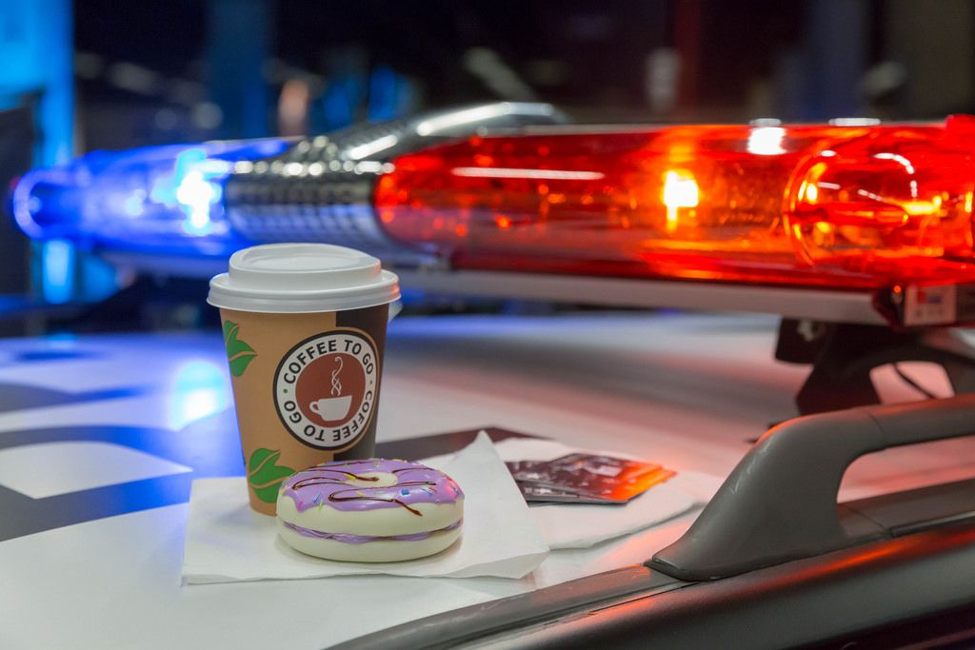
COME JOIN YOUR NEIGHBORS AND CRESTWOOD POLICE OFFICERS FOR COFFEE AND CONVERSATION!
Ask questions, tell us about your neighborhood, or share your concerns.
Chick-fil-A
13050 S. CICERO
10:00 – 1100 AM
Tuesday, April 14, 2026

